Assignment No. 8.1

1. When to use (Rapid Application Development) RAD model. When not to use (Rapid Application Development) RAD model

Ans: Rapid Application Development (RAD) model can be used only for Big budget projects where the budget permits us to purchase software for automated coding and we have higher availability of designers for modelling. It should be used only when a system can be modularized to be delivered in an incremental manner. We can incorporate the RAD model only if we have higher availability of domain experts with relevant business knowledge in our team. RAD uses complicated softwares were we need to put the inputs into a specific template and we will get the application code automatically wrtitten. So the developers need to make some little changes to these codes to ensure that they function according to the customer requirements. These softwares are highly expensive so we need higher budgets to incorporate RAD. It can be used when we need to accomodate changes during the course of the project and working prototypes are to be presented to customers in small iterations. It can be used for a project where the prime importance for the customer is shorter time in software development.

Rapid Application Model cannot be used when we have projects with low budgets and we do not have required designers for modelling in our team. It is not suitable for projects which requires higher levels of quality as in RAD here the teams are ready to compromise on quality and accept lower quality software if rapid delivery of essential functionality is possible.

2. Define an ER diagram of a software Organization with all the relationship model that was discussed in the classroom

Ans: ER diagram explaining the functioning of an Information Support (ITS) Employee working for different projects in a software Organization

Employee
Name
Works
for
Project Name
M
ITS
M
supports

M
Employee
Projects
M
Project
Duration

1
access
Employee ID
M

Timesheets
Account
Number

1
Salary Account

P.M Name
PAN Number
M
Project Manager

M
P.M ID

Fund
Transfer

M
Accountant
ID

M
Approves
Finance
Department

M

Accountant
Name

Route Map:

1.
= Entity

2.
= Attribute

3. = Action

4. M M = Many to Many

5. 1 1 = One to One

6. 1 M = One to Many

7. M 1 = Many to One

3. Describe the Entity Relationships for the following diagram
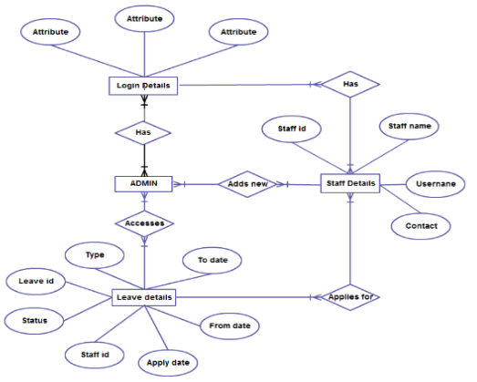

Ans: Entity diagram is a graphical representation of entities and their relationships to one another.
Entities:
1. Login Details
2. Admin
3. Staff Details
4. Leave details
Here the Login details include different attributes say for eg it can be Employee code, Employee DOB and employee password.
Scenario 1:
When employee enters these details he will login to his account. Then he can access staff details page with another user name and password where he can view his staff name staff ID and contact details. Then from here he has the provision to apply for leave. And for applying for the leave the employee needs to add details like Leave type like casual leave or sick leave. Then the date/s on which he needs the leave, the staff ID, the applying date, the period of leave (From date and to date). Then this leave details are sent to the Admin for getting the approval. The admin can approve or reject the request. When the admin sees the request he can access the leave details entity where he can see the leave details and employee details. Here when we consider the staff details the Staff ID is a primary key there, and we get all Employee details when we enter the Staff ID into it. The same Staff ID is a foreign key on the Leave details entity and the Leave ID is the primary key here.

Relationship between the entities:
Login details and Staff Details:
- There exists a many to many relation
- Different employees has different login details and has different details.
Staff details and Leave details:
- There exists a many to many relation
- different employees have different details and different leave requirements
Leave details and Admin:
- There exist a one to many relation between Admin and Leave details
- one admin has access over many employee leave requests at his branch.

Scenario 2:
Admin adds a new employee and adds his details in the staff details along with the newly alloted Staff ID. Then if the staff acces his account he can login with the newly alloted user name and password and change his username and password. Then he gets the login to the employee details and he cannot edit the details as Admin has only the authority to edit it. From there he can apply for the leave whenever required and the cycle continues as in Scenario 1.

